Practical #8
Practical Title:
To design and execute automated test scripts using Selenium for functional testing
Theory:
1. What is Functional Testing?
Functional testing is a type of software testing that verifies whether an application works according to the specified requirements and functions correctly.
It checks:
- Input → Output behaviour
- Features and functionality
- User interactions
Example:
Checking if a login button works correctly when valid/invalid credentials are entered.
2. Advantages of Selenium for Testing:
Selenium is widely used for automation testing.
Advantages:
- Open Source – Free to use
- Supports Multiple Languages – Java, Python, C#, etc.
- Cross-Browser Testing – Works on Chrome, Firefox, Edge
- Automates Repetitive Tasks – Saves time and effort
- Parallel Testing – Run multiple tests at once
- Integration Support – Works with tools like TestNG, Jenkins

Procedure:
Step 1: Setup Selenium environment
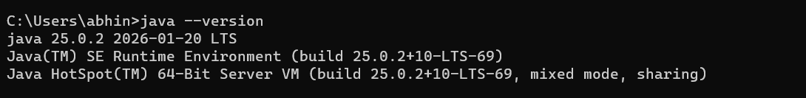
Java Installation Verified
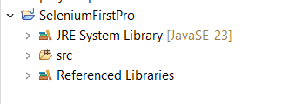
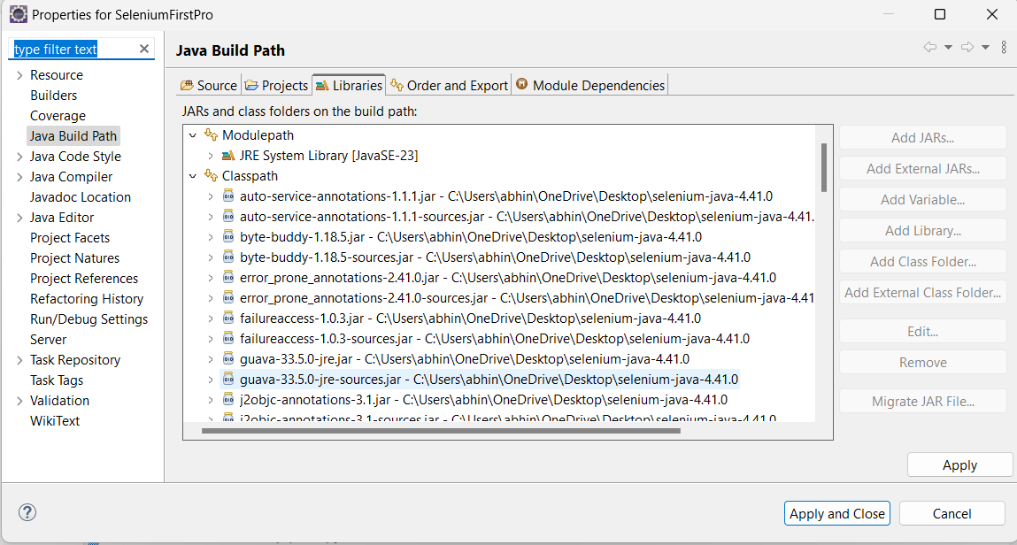
Step 2: Launch browser using WebDriver
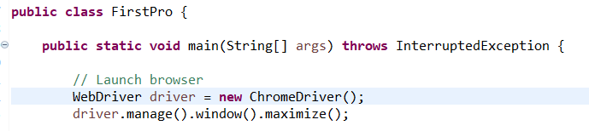
Step 3: Navigate to a web application
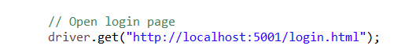
Step 4: Locate elements using locators (id, name, xpath, etc.)
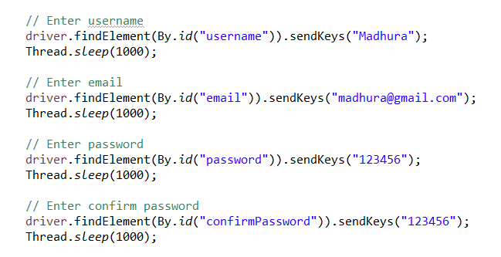
Step 5: Perform actions (click, send keys, submit)
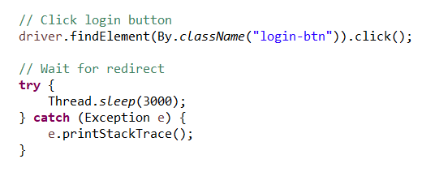
Step 6: Validate output using assertions
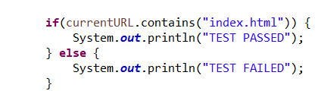
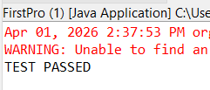

Step 7: Close the browser
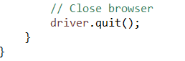
Activity / Task:
Task 1:
Write a Selenium script to test login functionality of a website.
Code:
package com.selenium.test;

import org.openqa.selenium.By;
import org.openqa.selenium.WebDriver;
import org.openqa.selenium.chrome.ChromeDriver;

public class FirstPro {

public static void main(String[] args) throws InterruptedException {

// Launch browser
WebDriver driver = new ChromeDriver();
driver.manage().window().maximize();

// Open login page
driver.get("http://localhost:5001/login.html");

// Enter username
driver.findElement(By.id("username")).sendKeys("Madhura");
Thread.sleep(1000);

// Enter email
driver.findElement(By.id("email")).sendKeys("madhura@gmail.com");
Thread.sleep(1000);

// Enter password
driver.findElement(By.id("password")).sendKeys("123456");
Thread.sleep(1000);

// Enter confirm password
driver.findElement(By.id("confirmPassword")).sendKeys("123456");
Thread.sleep(1000);

// Click login button
driver.findElement(By.className("login-btn")).click();

// Wait for redirect
try {
Thread.sleep(3000);
} catch (Exception e) {
e.printStackTrace();
}

// Check if redirected to index.html
String currentURL = driver.getCurrentUrl();

if(currentURL.contains("index.html")) {
System.out.println("TEST PASSED");
} else {
System.out.println("TEST FAILED");
}
Thread.sleep(10000);
// Close browser
driver.quit();
}
}
Task 2:
Test form submission with valid and invalid inputs.
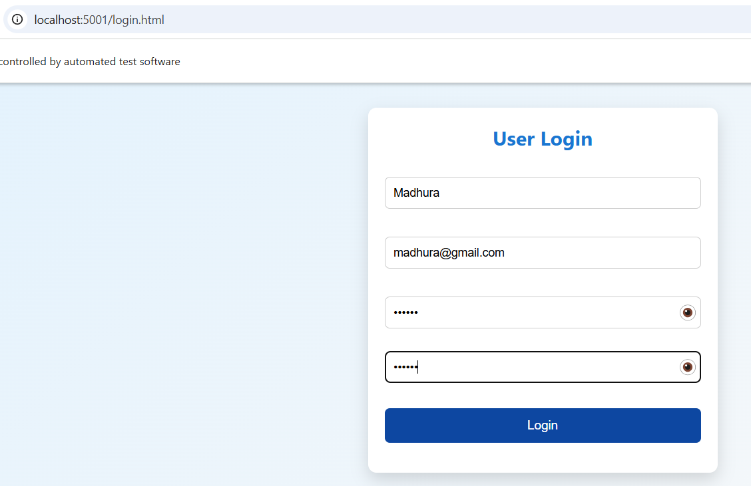
Description:
This screenshot shows the successful execution of automated testing on the login page of the Student Notes Application using Selenium.
The test script automatically launched the browser and navigated to the login page hosted on localhost (http://localhost:5001/login.html). Selenium then performed the following actions:
- Entered the username (“Madhura”)
- Entered the email address (“madhura@gmail.com”)
- Entered the password and confirm password fields
- Verified that all input fields accept data correctly
The message “controlled by automated test software” at the top of the browser confirms that the browser is being controlled by Selenium WebDriver.
Advantages
1. Automation of Testing – Selenium allows automation of repetitive and time-consuming manual test cases, which increases efficiency and reduces human errors.
2. Cross-Browser Compatibility – It supports multiple browsers such as Chrome, Firefox, Edge, and Safari, ensuring that the application works consistently across different platforms.
3. Reusability of Test Scripts – Once created, test scripts can be reused multiple times for regression testing, saving both time and effort in long-term projects.
4. Faster Execution of Test Cases – Automated tests can run much faster than manual testing and can execute multiple test cases simultaneously, improving productivity.
5. Multi-Language Support – Selenium supports various programming languages like Java, Python, C#, and JavaScript, making it flexible for developers with different skill sets.
Challenges
1. Requires Programming Knowledge – Selenium requires understanding of programming concepts, which can be difficult for beginners or non-technical testers.
2. High Maintenance Effort – If the application’s UI or structure changes frequently, test scripts need to be updated regularly, increasing maintenance effort.
3. No Built-in Reporting or Test Management – Selenium does not provide built-in reporting features, so additional tools like TestNG or JUnit are required for generating reports and managing test cases.
Conclusion
Automated test scripts were successfully designed and executed using Selenium for functional testing. The process demonstrated how automation improves testing efficiency, accuracy, and speed. It also highlighted the importance of scripting and tool integration in modern software testing.

